Allegra Fuller Snyder

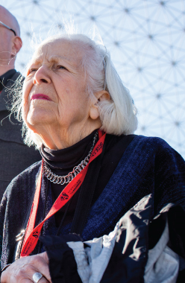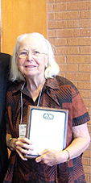
choreographer director educator
Allegra Snyder is an American choreographer, film director and educator. She is a professor emeritus of dance and dance ethnology at the University of California at Los Angeles.

Background
Snyder was born on August 28, 1927 in Chicago, Illinois, United States; the daughter of Buckminster Fuller and Anne (Hewlett) Fuller.

Education
Snyder attended the School of American Ballet from 1941 to 1947. She received a Bachelor of Arts degree in Dance from Bennington College in 1951. Sixteen years later she was given a Master of Arts degree in Dance from the University of California at Los Angeles.

Career
Snyder began her career as a chair of Dance Department at the University of California at Los Angeles in 1974 and held it for six years and again in Spring 1984 and from 1990 to 1991. Also in 1972, she took a position of a founding coordinator and chair for the Ethnic Arts Program at World Arts and Cultures Department at the same university, where she served until 1983.
Also in 1982, she took a position of a visiting professor of performance studies at New York University. A year later Allegra became an honorary visiting professor at the University of Surrey, where she worked until 1984. She has also taught at California Institute of the Arts and at Naropa Institute. In 1989, Allegra was appointed a chair of the Faculty of the School of Arts at the University of California and held the position until her retirement in 1991. Since 1991 she has been a professor emeritus of dance and dance ethnology at that university.
In November 1986 she was delegate of the American Institute of Indian Studies to attend the inauguration of the Indira Gandhi National Center for Arts in New Delhi. Then in December 1987 Snyder was a participant in the Eleventh Taniguchi Foundation International Symposium.
She was a selected presenter at the Hong Kong International Dance Conference in July 1990. Snyder delivered papers at meetings of the Study Group on Ethnochoreology of the International Council for Traditional Music in Copenhagen in 1988, Naplion in 1992 and Korcula in 2000. She served as conference co-organizer for the 1994 meeting in Poland.
She organized and presented "A Look at Dance and Its History," a series of seven lectures with extensive use of film, including the first showing on the West Coast of Martha Graham's "Night Journey" at New Dance Theatre in Los Angeles in 1961.
Snyder has directed a number of films on dance including "Bayanihan", "Gestures of Sand", "Reflections on Choreography". When she received a grant from the National Endowment for the Humanities, she made the films "Baroque Dance", 1675-1725 and "When the Fire Dances Between the Two Poles", a film on Mary Wigman.
More photos

Achievements
- Snyder is cited in The Who's Who in America, Who's Who of American Women, Who's Who in Society, Who's Who in the West, World Who's Who of Women in Education and others.
She received a grant from National Endowment for the Arts in 1981, National Endowment for the Humanities in 1977 and the University of California in 1968.

Works
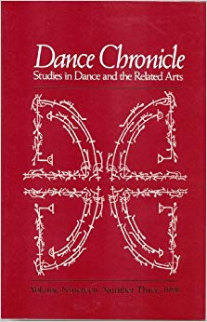
- book
  - Dance Chronicles (Special Section in honor of Selma Jeanne Cohen, plus essays on The Arabesque, Renaissance and Baroque dance, Elizabetta Menzeli, and Lincoln Kirsten; translations of August Bournonville, Studies in Dance and the Related Arts, Volume 19, Number 3, 1996) 1996

Membership
Snyder was a chairperson of the Congress on Research in Dance from 1975 to 1977. She worked in various capacities on the Dance Program of the National Endowment for the Arts. Allegra has been a seminar director of the Summer Programs for College Teachers.
She has also served as panelist and reader on the Advisory Screening Committee and Council for International Exchange of Scholars. Snyder worked on the Executive Committee in Western Division of the Association of American Dance Companies in 1971-1976.
Since 1983 she has served as an executive director, president, chairperson and now as an honorary member of the Board of Directors at the Buckminster Fuller Institute.

Connections
On June 30, 1951 Allegra Snyder married Robert Snyder, with whom she divorced in April 1975 and remarried in September 1980. They have 2 children.
Father:
Buckminster Fuller
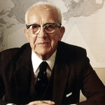
Mother:
Anne Hewlett
Spouse:
Robert Snyder
child:
Alexandra Snyder
child:
Jaime Snyder

